tHE BOARD OF EDUCATION School District 83
(nORTH OKANAGAN- SHUSWAP)
COVID -19 SAFETY PLAN
Stage 2, Version 5 August 5.1, 2020
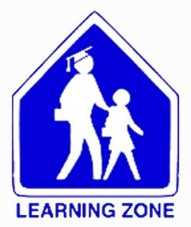
Table of Contents
1. INTRODUCTION: 5
2. BC MINISTRY OF EDUCATION FOUNDATIONAL PRINCIPLES 5
3. GUIDANCE: 6
4. DEFINITIONS 7
5. RESPONSIBILITIES: 7
6. SAFETY MEASURES FOR SEPTEMBER OPENING 8
6.1. What Can Parents & Students Expect in Stage 2? 8
6.1.1. Regular Communication 8
6.1.2. In-Class Instruction & Supports 8
6.1.3. Enhanced Health & Safety Measures 8
7. RESOLVING CONCERNS ABOUT UNSAFE WORK 9
8. LEGISLATIVE QUESTION OR CONCERNS 9
9. PROTECTING MENTAL HEALTH 9
10. INFECTION PREVENTION AND EXPOSURE CONTROL MEASURES: 10
10.1. Public Health Measures: 11
10.2. Environmental Measures: 11
10.3. Administrative Measures: 11
10.4. Personal Measures: 11
10.5. Personal Protective Equipment 11
11. ADMINSTRATIVE MEASURES 11
11.1. Training: 11
11.2. Cohorts 12
11.3. Interacting with Cohorts 13
11.4. School Gatherings 14
11.5. Physical Distancing 14
11.6. Other Strategies 14
11.7. Extracurricular Activities 15
12. UNDERSTANDING AND ASSESSING THE RISK OF COVID-19 TRANSMISSION 15
12.1. Understanding the Risk 16
13. BACKGROUND: 16
13.1. What We Know About Covid-19 in Children 16
13.2. COVID-19 and Adults 17
13.3. COVID-19 and Schools 17
14. INFECTION PREVENTION AND EXPOSURE CONTROL MEASURES 17
15. OFFICE EVENTS 18
15.1. Elimination Controls 18
15.2. Engineering Controls 18
15.3. Administrative Controls 19
15.4. Personal Protective Equipment 19
15.5. Wearing a mask if you are healthy 20
16. If A Child or Staff Member Is Ill 20
16.1. When to Stay Home 20
16.2. Sick While at Work or School 21
16.2.1. If a Student Develops Any Symptoms of Illness 21
16.2.2. If a Staff Member Develops Any Symptoms of Illness 21
16.3. Case Finding, Contact Tracing and Outbreak Management 22
16.4. Self-Isolation for International Travelers Returning to B.C. 22
17. ENVIRONMENTAL MEASURES 22
17.1. Visitors to District Buildings and Facilities 24
17.2. Payments (Parent Connect, E-transfers, Personal Checks, and Cash) 25
17.3. Shared Space with Lessees 25
17.4. Application Process for Vital Oxide 25
18. CLEANING PROCEDURES FOR NOTEBOOKS, ALL-IN-ONE DESKTOPS, AND MONITORS: 26
18.1. Caring for Technology 26
A. Cleaning your Computer Keyboard 26
B. Cleaning your Computer LCD Display 27
C. Disinfecting your computer, keyboard and LCD Display 27
19. SCHOOL ARRIVAL PROCEDURES 28
19.1. Student at Home Health Check: 29
19.2. Visitor Health Check: 30
20. ADMINISTRATIVE MEASURES 30
20.1. Physical Distancing and Minimizing Physical Contact 30
20.2. Where physical distance cannot be maintained. 32
20.3. Communication Plans and Training 32
21. SAMPLE PROTOCOLS TO MAINTAIN SCHOOL ADMINISTRATIVE MEASURES: 32
21.1. Photocopy Room 33
21.2. Office 33
21.3. Daily Announcements 33
21.4. Crossing Guard Duty 33
21.5. Supervision 33
21.6. Arrival/Drop-Off and Dismissal/Pick-up 33
21.7. Lunch & Recess 33
21.8. Staff Room 34
21.9. Gym 34
21.10. Hallways 34
21.11. Music 34
21.12. Student Washrooms 35
21.13. Library 35
21.14. Student Behavior 35
21.15. Drinking Water 35
21.16. Custodial Cleaning Protocols 35
22. Student Transportation on Buses 36
22.1. Additional Measures: 37
22.2. Transportation Non-Compliance with COVID-19 Safety Protocols 37
23. Food Services 37
24. PERSONAL MEASURES 38
24.1. Hand Washing 38
24.2. Strategies to Ensure Diligent Hand Hygiene: 39
24.3. Hand Washing Staff and Children Should Perform Hand Hygiene: 39
24.3.1. Students 39
24.3.2. Staff 39
24.4. Hand Sanitizer: 39
24.5. Coughing and Sneezing Etiquette 40
25. PERSONAL PROTECTIVE EQUIPMENT 40
25.1. PPE: 40
25.2. Students with Diverse Abilities 41
25.3. Non-Medical Masks 41
26. Auditing 42
27. Revision Status 42
Section 25 – Update PPE 44
Section 26 - Auditing 44
Appendix 9-14 44
APPENDIX: 44
1. POSTER LINKS: 45
2. AUTHORIZED PERSONNEL 45
3. HAND SANITIZING STATION 47
4. HAND WASHING – STUDENTS 48
5. HAND WASHING – STAFF 49
6. MEDICAL ISOLATION ROOM 50
7. VISITOR CHECK LIST 51
8. WASHROOM CLEANING LOG 52
9. SAFE WORK PROCEDURE: FIRST AID PROTOCOLS – COVID-19 53
8. Year End Gatherings 56
9. How to Use a Mask 57

INTRODUCTION:
The Board of Education of School district No. 83 recognizes that the information in this Safety Plan is fluid and at any time may change as Ministry Information changes or COVID-19 evolves. While School District No.83 will try to keep the information timely and accurate the revision status is crucial. Please ensure that you visit https://healthandsafety.sd83.bc.ca/ for the latest and most updated version.

The Purpose of this document is to outline control measure to minimize or eliminate the potential for transmission of communicable disease. In order to coordinate the district’s response and safety measures, a combination of measures will be used to minimize the potential of exposure at school and building sites to the pathogen known as COVID -19. The Board of Education of School District No. 83 is committed to ensuring all our schools are safe.

In September 2020, School District No. 83 will start up in Stage 2 with the goal of maximizing in-class instruction for all students according to the revised public health guidelines to reduce the risk of COVID-19 transmission. Having students in the classroom helps to minimize learning gaps and provide the academic, social and emotional supports essential for learning.

Based on the current epidemiology of COVID-19 in B.C., and the fact that children are at a much lower risk of developing and transmitting COVID-19, School District No. 83 is able to have all elementary and middle school students, and most secondary students receive daily in-class instruction within the school environment.

The Ministry of Education Five Stage Framework for K-12 includes comprehensive COVID-19 health and safety measures and aligns with B.C.’s Restart Plan. Based on new public health guidance for K-12 schools from the Provincial Health Officer, the Five Stages have been updated to outline expectations for B.C. elementary, middle and secondary schools for the 2020/21 school year. This includes organizing students into cohorts (Learning Groups) to help limit contact and potential exposure.

BC MINISTRY OF EDUCATION FOUNDATIONAL PRINCIPLES
- Maintain a healthy and safe environment for all students, families and staff.
- Provide the services needed to support the children of our essential workers (ESWs).
- Support vulnerable students who may need special assistance.
- Provide continuity of educational opportunities for all students.
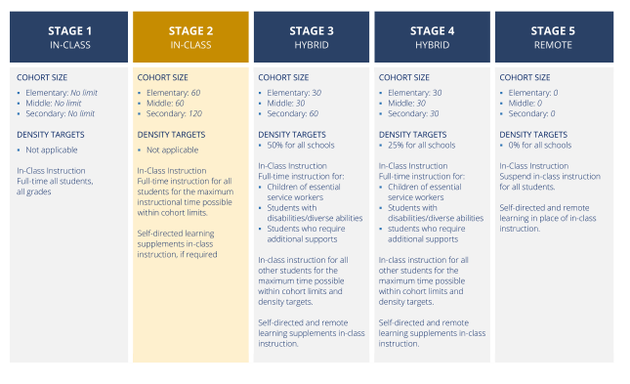

GUIDANCE:
This Safety Plan is informed by the following:
- COVID-19 Public Health Guidance for K-12 School Settings
- BC's Back to School Plan
- Next Steps to Move BC through the Pandemic
- K-12 Education Restart Plan
- BC COVID-19 Go-Forward Management Strategy,
- BC’s COVID-19 Go-Forward Management Checklist
- WorkSafe BC’s COVID-19 Information and Resources and COVID-19 Frequently Asked Questions.
- WorksafeBC Returning to Safe Operation
- Worksafebc A Guide For Employers And Occupational First Aid Attendants
- Order of the Provincial Health Officer
- Key Steps To Safely Operating Your Business Or Organization And Reducing Covid-19 Transmission
- Guidelines for Re-Entry into the School Setting During the Pandemic: Managing the Social-Emotional and Traumatic Impact
- Guidance for Food Service Establishments and Liquor Services, Including Restaurants, Cafés and Pubs
- SickKids Updated Guidance for School Reopening
- Symptoms of Covid-19
- BC COVID-19 Self-Assessment Tool
- Self-Isolation on Return to BC
- Vulnerable Populations
- Information for Those with Chronic Health Conditions
- Strong Start

DEFINITIONS

Health Hazard means
- A condition, a thing or an activity that:
  - Endangers, or is likely to endanger, public health, or
  - Interferes, or is likely to interfere, with the suppression of infectious agents or hazardous agents, or
- A prescribed condition, thing or activity, including a prescribed condition, thing or activity that:
  - Is associated with injury or illness, or
  - Fails to meet a prescribed standard in relation to health, injury or illness.
Undue Hazard is an “unwarranted, inappropriate, excessive, or disproportionate” hazard. For COVID-19, an “undue hazard” would be one where a worker’s job role places them at increased risk of exposure and adequate controls are not in place to protect them from that exposure.

RESPONSIBILITIES:

Employers are responsible for the health and safety of their workers, and all other workers at their workplace. They are responsible for completing and posting the COVID-19 Safety Plan and to train and educate everyone at the workplace of the contents of that plan. Employers are also responsible for having a system in place to identify the hazards of COVID-19, control the risk, and monitor the effectiveness of the controls.
Workers are responsible for taking reasonable care to protect their own health and safety and the health and safety of other people at workplace. In the context of COVID-19, this means workers are responsible for their own personal self-care, which includes frequent hand washing and staying home when sick. Workers are also responsible for reporting unsafe conditions to their employer, and following the procedures put in place by the employer to control the risks associated with COVID-19.
The owner or the prime contractor (in our case, the School District) is responsible for coordinating health and safety at a workplace where workers of two or more employers are working at the same time. This includes doing everything that can reasonably be done to establish and maintain a system or process to ensure compliance with WorkSafeBC laws and regulations generally, including ensuring an effective system to control the risks associated with COVID-19.
Occupational First Aid Attendants (OFAA’S)
During the COVID-19 pandemic, occupational first aid attendants (OFFA’S) continue to provide treatment to workers as necessary. Because of the possibility of community infection, you may need to modify your standard protocols for first aid treatment to reduce the potential for transmission. Please see the attached safe work practice for precautions.

SAFETY MEASURES FOR SEPTEMBER OPENING

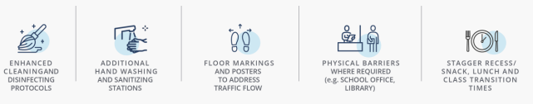
On September 8, 2020, School District No. 83 will begin the new school year with the goal to maximize in-class learning for all students. To support the return to school the above COVID-19 safety measures are being implemented to help protect students, staff, contractors, visitors and volunteers.

  - What Can Parents & Students Expect in Stage 2?
Given the permitted sizes of cohorts, it is expected that elementary and middle school students will return to full-time, in-class instruction with minimal modifications to school structures and timetables. Our secondary schools will be making adjustments to timetables and school schedules to ensure all students can attend school on a full-time basis and maximize in-class instruction. Parents and students can also expect:
    - Regular Communication
- Contact from school or district to confirm educational program options for September.
- Regular information updates on school and district websites.

    - In-Class Instruction & Supports
- Full return to in-class instruction provided that all required health and safety measures can be accommodated.
- Full-time instruction for students with disabilities/diverse abilities and students requiring additional support.
- Focus on mental health and well-being supports for students returning to school.
- Options for students with underlying complex medical needs.

    - Enhanced Health & Safety Measures
- Parents will be asked to monitor their children daily for symptoms and not to send them to school if they are sick.
- Students will be asked to wash their hands frequently, including before coming to school. They will have access to hand sanitizer when hand washing is not available.
- Schools will continue to be cleaned more frequently, including classrooms and high touch areas.
- Schools and classrooms might look different:
- Organizing students into cohorts,
- Increased spacing between students in classrooms and more individual and smaller group activities,
- Limitations on assemblies and other large gatherings,
- Wearing non-medical masks will required for students in grades 6-12 and staff in common areas in schools and on buses. Masks for younger students will be made available and provided upon request.
- Students will be asked to label their personal items and not to share them.
- Parents may need to remind children to minimize physical contact with their friends.
Special Note: Please see further in document for more details on enhanced Health and Safety Measures.

RESOLVING CONCERNS ABOUT UNSAFE WORK
Workers have the right to refuse work if they believe it presents an undue hazard. If the matter is not resolved, the worker and the supervisor or employer must contact WorkSafeBC. Once that occurs, a prevention officer will consult with workplace parties to determine whether there is an undue hazard and issue orders if necessary
For more information, see Occupational Health and Safety Guideline G3.12.

JOINT HEALTH AND SAFETY COMMITTEES

What Is The Role Of My Joint Health And Safety Committee Or Worker Representative?
Occupational joint health and safety committees play an important role in helping School District No. 83 establish and maintain healthy and safe workplaces.
The committee gives workers and employers a way to work together to identify and find solutions to workplace health and safety issues, which includes health and safety concerns related to COVID-19. The joint committee or representative must:
- Identify situations that may be unhealthy or unsafe for workers, and advise on effective systems for responding to those situations.
- Consider and promptly deal with complaints relating to the health and safety of workers.
- Consult with workers and the employer on issues related to occupational health and safety, and the occupational environment.
- Make recommendations to the employer and workers for improving the occupational environment.
- Advise School District No.83 on programs and policies required under the regulations for the workplace, and monitor their effectiveness.
- Advise School District No.83 on proposed changes to the workplace, including significant proposed changes to equipment and machinery, or the work processes that may affect the health or safety of workers.

School District No. 83 Joint Health and Safety Committees Must Be Meaningfully Engaged In Protecting The Workplace Against COVID-19.
Some Strategies School District No. 83 will be utilizing are:
- Ensuring there is a mechanism in place where workers can raise any concerns about the risk of COVID-19 exposure at the workplace to the joint committee or worker representative. Please ensure that there is a line item in all agenda’s related to COVID-19. Engage the use of the HR Coordinator Health Safety and Wellness, Brenda MacKay at 250-253-5746, for any assistance you may require.
- Have committee members participate in a walk-through assessment of the work process(es) to identify potential areas of increased risk and priority action. HR Coordinator Health Safety and Wellness will be conducting Audits of the Safety Plan so participation of committee members are vital.
- Ensure that the joint committee is involved in the development of control plans for different job tasks.
- Joint Health and Safety Committees must be involved in promoting approved social distancing measures.
- Joint Health and Safety Committees will be required to provide feedback on the effectiveness of control measures implemented.

School District No. 83 Health And Safety Committees Will Continue To Meet During The COVID-19 Outbreak.
- Joint health and safety committees must continue to meet regularly as required under the Occupational Health and Safety Regulation. School District No. 83 will hold meetings remotely for some or all participants, through the use of Teams Meetings, to encourage physical distancing.
- For those that can Physical distance meetings may take place within the facilities.

LEGISLATIVE QUESTION OR CONCERNS
Workers and employers with questions or concerns about workplace exposure to the COVID-19 virus can call WorkSafeBC’s Prevention Information Line at 604.276.3100 in the Lower Mainland (toll-free within B.C. at 1.888.621.SAFE). You’ll be able to speak to a prevention officer to get answers to your questions, and if required, a prevention officer will be assigned to assess the health and safety risk at your workplace.

PROTECTING MENTAL HEALTH
Workers in the workplace may also be affected by the anxiety and uncertainty created by the COVID-19 outbreak. It’s important to remember that mental health is just as important as physical health, and to take measures to support mental well-being. Here are some resources that can assist with maintaining mental health in the workplace during this time.
- COVID-19 Psychological First Aid Service: Information and Signup (British Columbia Psychological Association) – Free virtual counselling provided by registered psychologists.
- COVID-19: Staying Well in Uncertain Times (Canadian Mental Health Association – B.C.) – Tips and information on how to reduce and manage anxiety in the workplace due to the COVID-19 outbreak.
- Managing COVID-19 Stress, Anxiety and Depression (Ministry of Mental Health and Addictions) - Tips and resources on things we can do as individuals and collectively to deal with stress and support one another during these challenging times.
- Mental Health and Psychosocial Considerations During COVID-19 Outbreak (World Health Organization) – These mental health considerations were developed by the WHO’s Department of Mental Health and Substance Use as messages targeting different groups to support for mental and psychosocial well-being during COVID-19 outbreak.
- Mental Health and COVID-10 (Conference Board of Canada) – Videos on different aspects of mental health, including coping with anxiety, job loss, and dealing with isolation.
- Taking Care of Your Mental Health (COVID-19) (Public Health Agency of Canada) – Tips and resources for taking care of your mental health during the COVID-19 outbreak.
- Life Works SD83 EAP. Username: shuswapsd83 Password: healthy
- Talk to your Supervisor, Union Rep or HR Coordinator Health Safety and Wellness for assistance and navigation through these unprecedented times.

INFECTION PREVENTION AND EXPOSURE CONTROL MEASURES:

Infection prevention and exposure control measures help create a safe environment for students and staff. Infection Prevention and Exposure Control Measures for Communicable Disease describes measures that can be taken to reduce the transmission of COVID-19. Control measures at the top are more effective and protective than those at the bottom. By implementing a combination of measures at each level, the risk of COVID-19 is substantially reduced.
The Hierarchy for Infection Prevention and Exposure Control Measures for Communicable Disease
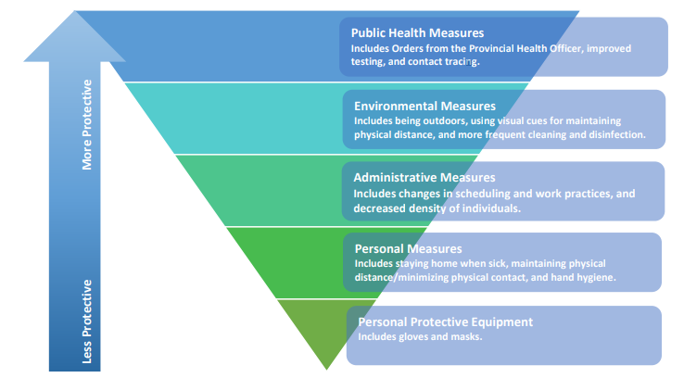
  - Public Health Measures:
Are changes to the physical environment that reduce the risk of exposure. Examples include being in outdoor spaces, using visual cues for maintaining physical distance or directing traffic flow in hallways, erecting physical barriers where appropriate and frequent cleaning and disinfection.

  - Environmental Measures:
Are changes to the physical environment that reduce the risk of exposure. Examples include being in outdoor spaces, using visual cues for maintaining physical distance or directing traffic flow in hallways, erecting physical barriers where appropriate and frequent cleaning and disinfection.

  - Administrative Measures:
Are measures enabled through the implementation of policies, procedures, training and education. Examples of these include health and wellness policies, decreased density in classrooms, staggered schedules and using virtual learning opportunities.

  - Personal Measures:
Are actions individuals can take to protect themselves and others. Examples include maintaining physical distance/minimizing physical contact, washing your hands frequently, coughing into your elbow and staying home from work if you are sick.

  - Personal Protective Equipment: (PPE)
Is the last and least effective of the infection prevention and exposure control measure and should only be considered after exploring all other measures. PPE is not effective as a stand-alone preventive measure, should be suited to the task, and must be worn and disposed of properly. Outside of the health care settings, the effectiveness of PPE is generally limited to protecting others should you be infected.
School District No. 83 has implemented a combination of measures at different levels, as described in this document. This document includes Environmental, Administrative, Personal Measures and the use of PPE.

ADMINSTRATIVE MEASURES

  - Training:
Health and safety training and orientation of school district staff, including new employees and staff who work at multiple sites and/or across multiple cohorts in a school (i.e. counsellors, learning assistants, prep teachers, Education Assistants) will take place prior to students returning. These orientations will take place at schools on September 8 and 9.

  - Cohorts
Reducing the number of in-person, close interactions an individual has in a day with different people helps to prevent the spread of COVID-19. This can be accomplished in our K-12 school settings through two different but complementary approaches: Learning Groups or cohorts and physical distancing.
- A cohort is a group of students and staff who remain together throughout a school term.
- Physical distancing is maintaining a distance of two metres between two or more people.
Cohorts reduce the number of in-person, close interactions a person has in school without requiring physical distancing to consistently be practiced.
  - In elementary and middle schools, a cohort can be composed of up to 60 people.
  - In secondary schools, a cohort can be composed of up to 120 people.
  - Cohorts can be composed of students and staff.
Cohorts are smaller in elementary and middle schools due to the recognition that younger children are less able to consistently implement personal measures such as hand hygiene, reducing physical contact and recognizing and articulating symptoms of illness.
Cohorts are larger in secondary schools due to the increased ability of children in that setting to be able to consistently minimize physical contact, practice hand hygiene, ensure physical distance where necessary and recognize and articulate symptoms of illness.
School administrators should determine the composition of the cohorts. The composition of the cohort should remain consistent for all activities that occur in schools, including but not limited to learning and breaks (lunch, recess, classroom changes, etc.). Within the cohort minimized physical contact should be encouraged, but a two-meter physical distance does not need to be maintained.
Cohort composition can be changed at the start of a new quarter, semester or term in the school year. Outside of these, composition should be changed as minimally as possible, except where required to support optimal school functioning. This may include learning, operational or student health and safety considerations.
Consistent seating arrangements are encouraged within cohorts where practical. This can assist public health should contact tracing need to occur.
School District 83 administrators must keep up-to-date lists of all members of a cohort to share with public health should contact tracing need to occur.
  - Interacting with Cohorts

School District 83 will minimize the number of adults (staff and others) who interact with cohorts they are not a part of as much as is practical to do so while supporting learning and a positive, healthy and safe environment.
Those outside of a cohort (i.e. prep teachers, remedy teachers, music teachers, TTOCs, casual support staff, etc.) must practice physical distance when interacting with the cohort. For example, a secondary school teacher can teach multiple cohorts but should maintain physical distance from students and other staff as much as possible. In an elementary or secondary school, two classes from different cohorts can be in the same learning space at the same time if a two-metre distance is able to be maintained between people from different cohorts.
Face Shields or plexiglass barriers can be issued to those outside cohorts that are required to instruct students on an infrequent basis.
During break times (i.e. recess, lunch), students may want to socialize with peers in different cohorts.
- In elementary schools, students can socialize with peers in different cohorts if they are outdoors and can minimize physical contact or if they are indoors and can maintain physical distance.
  - Elementary-aged students are less able to consistently maintain physical distance. Outdoors is a lower risk environment than indoors.
- In middle and secondary schools, students can socialize with peers in different cohorts if they can maintain physical distance. Students must maintain physical distance when socializing with peers in different cohorts.
  - Middle and secondary school students are expected to be capable of consistently maintaining physical distance when it is required. If a student is unable to physically distance, the student should socialize within their cohort or where they can be supported to physically distance.
Unless they are part of the same cohort, staff and other adults should maintain physical distance from each other at all times. This includes during break times and in meetings.
Students from different cohorts may be required to be together to receive beneficial social supports, programs or services (i.e. meal programs, after school clubs, etc.). Within these supports or services, it is expected that cohorts and physical distance are maintained as much as is practical to do so while still ensuring the support, program or service continues. This does not apply to extracurricular activities where physical distance between cohorts must be maintained.
Elementary and middle schools are likely able to implement cohorts without reducing the number of individuals typically within the school. Secondary schools may use both approaches: implement cohorts and reduce the number of individuals typically within the school to enable physical distance for out-of-cohort interactions. This may be necessary due to the larger number of people and the increased frequency of classroom exchanges that typically occur within secondary schools.
If physical distancing cannot be maintained between cohorts of students in grades 6-12, masks must be worn.
  - School Gatherings
School gatherings should occur within the cohort.
  - Gatherings should not exceed the maximum cohort size in the setting, plus the minimum number of additional people required (i.e. school staff, visitors, etc.) to meet the gathering’s purpose and intended outcome.
  - Additional people should be minimized as much as is practical to do so.
  - These gatherings should happen minimally.
  - Schools should seek virtual alternatives for larger gatherings and assemblies.

  - Physical Distancing
Due to physical space limitations it may be necessary to reduce the number of individuals within secondary schools at any given time to ensure that physical distance can be maintained when required. Secondary schools should continue to prioritize the attendance of students who most benefit from in-person support and learners with diverse needs, as well as consider alternative learning modalities and off-campus learning.

  - Other Strategies
The following strategies should be implemented wherever possible in the K-12 school setting: • Avoid close greetings (i.e., hugs, handshakes).
- Encourage students and staff to not touch their faces. Spread people out as much as is practical to do so:
  - Consider different classroom and learning environment configurations to allow distance between students and adults (i.e., different desk and table formations).
- For middle and secondary schools, consider arranging desks/tables so students are not facing each other and using consistent seating arrangements.
- Consider strategies that prevent crowding at pick-up and drop-off times.
- Stagger recess/snack, lunch and class transition times to provide a greater amount of space for everyone.
- Take students outside more often:
  - Organize learning activities outside including snack time, place-based learning and unstructured time.
  - Take activities that involve movement, including those for physical health and education, outside.
  - Playgrounds are a safe environment. Ensure appropriate hand hygiene practices before and after outdoor play.
- Incorporate more individual activities or activities that encourage greater space between students and staff.
  - For elementary students, adapt group activities to minimize physical contact and reduce shared items.
  - For middle and secondary students, minimize group activities and avoid activities that require physical contact.
    - Manage flow of people in common areas, including hallways, to minimize crowding and allow for ease of people passing through.
    - Parents, caregivers, health-care providers, volunteers and other non-staff adults (i.e. visitors) entering the school should be prioritized to those supporting activities that are of benefit to student learning and wellbeing (i.e. teacher candidates, immunizers, meal program volunteers, etc.).
  - All visitors should confirm they have completed the requirements of a daily health check before entering.
  - Schools should keep a list of the date, names and contact information for all visitors who enter the school.

  - Extracurricular Activities
Extracurricular activities including sports, arts or special interest clubs can occur if physical distance can be maintained between members of different cohorts and reduced physical contact is practiced by those within the same cohort. Inter-school events including competitions, tournaments and festivals, will not occur at this time. This will be reevaluated in mid-fall 2020

UNDERSTANDING AND ASSESSING THE RISK OF COVID-19 TRANSMISSION
School District No. 83 will continue to assess the risk in our schools and buildings in order to identify places where the risk of transmission is introduced. This can be achieved through a collaborative approach with District staff and through the Joint Health and Safety Committee.
School District No. 83 encourages all workers who have safety concerns to raise those concerns to your joint health and safety committee member or for immediate assistance talk to your supervisor, union rep or HR Coordinator, Health Safety and Wellness.
The virus that causes COVID-19 spreads in several ways, including through droplets when a person coughs or sneezes, and from touching a contaminated surface before touching the face. Higher risk situations require adequate protocols to address the risk.
- The risk of person-to-person transmission is increased the closer you come to other people, the amount of time you spend near them, and the number of people you come near. Physical distancing measures help mitigate this risk.
- The risk of surface transmission is increased when many people contact same surface, and when those contacts happen in short intervals of time. Effective cleaning and hygiene practices help mitigate this risk.
  - Video: Transmission of the COVID-19 coronavirus
  - Video: Cough & sneeze etiquette
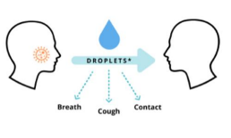
See SD83 Risk Assessment

Understanding the Risk

The virus that causes COVID-19 spreads in several ways, including through droplets when a person coughs or sneezes, and from touching a contaminated surface before touching the face. Higher risk situations require adequate protocols to address the risk.
- The risk of person-to-person transmission can vary depending on the closer you come to other people, the amount of time you spend near them, and the number of people you come near. physical distancing measures help mitigate this risk.
- The risk of surface transmission is increased when many people contact same surface, and when those contacts happen in short intervals of time.
- Effective cleaning and hygiene practices help mitigate this risk.

- BACKGROUND:

What We Know About Covid-19 in Children

- COVID-19 virus has a very low infection rate in children (ages 0 to19).
- In B.C., less than 1% of children tested have been COVID-19 positive, and even fewer are suspected to have been infected based on serological testing. Most children are not at high risk for COVID-19 infection. Children under 10 comprise a smaller proportion of the total confirmed child cases compared to children between the ages of 10 and 19.
- Based on published literature to date, the majority of cases in children are the result of household transmission by droplet spread from a symptomatic adult family member with COVID-19. Even in family clusters, adults appear to be the primary drivers of transmission.
- Children under one year of age, and those who are immunocompromised or have pre-existing pulmonary conditions are at a higher risk of more severe illness from COVID-19 (visit the BCCDC Children with Immune Suppression page for further details).
  - Children who are at higher risk of severe illness from COVID-19 can still receive in-person instruction. Parents and caregivers are encouraged to consult with their health-care provider to determine their child’s level of risk.
- Children typically have much milder symptoms of COVID-19, if any. They often present with low-grade fever and a dry cough. Gastrointestinal symptoms are more common than in adults over the course of disease, while skin changes and lesions are less common.

COVID-19 and Adults

While COVID-19 impacts adults more than children, some adults with specific health circumstances are at an increased risk for more severe outcomes, including individuals:
- Aged 65 and over,
- With compromised immune systems, or
- With underlying medical conditions.
Most adults infected with COVID-19 will have mild symptoms that do not require care outside of the home.
COVID-19 workplace accommodations for staff will require specific medical documentation indicating individuals are in the high-risk categories as per the BCCDC definition. All accommodation requests will be managed through the Human Resources department as per usual practice. Collaboration will take place with the appropriate unions as needed.

COVID-19 and Schools
    - There is limited evidence of confirmed transmission within school settings. This is partially due to wide-spread school closures worldwide at the onset of the pandemic to help prevent the spread of COVID-19.
      - In documented cases, there was typically minimal spread beyond the index case though isolated outbreaks have been reported.
    - Children do not appear to be the primary drivers of COVID-19 spread in schools or in community settings.
    - Schools and childcare facility closures have significant negative mental health and socioeconomic impacts on vulnerable children.
    - Prevention measures and mitigation strategies involving children must be commensurate with risk. This information is based on the best evidence currently available. It will be updated as new information becomes available. For up-to-date information on COVID-19, visit the BC Centre for Disease Control (BCCDC) website.

INFECTION PREVENTION AND EXPOSURE CONTROL MEASURES

Schools are considered a controlled environment by public health. This is because schools include a consistent grouping of people.
Within cohorts, physical distancing is not an expectation for students of School District No. 83 as per Ministry Direction. At the same time, it is important that we do what we can to try to assist children to understand the importance of minimizing the frequency of physical contact with one another. From a public health perspective, there are ratios are set that prescribe the number of adults and children that can be present in the same space at any given time. Please see the Return to Class Document for further information.
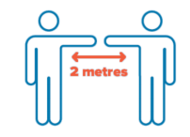

OFFICE EVENTS

Mass Gatherings: The Provincial Health Officer’s Order for Mass Gatherings continues to prohibit gatherings and events of people in excess of 50 people for the purpose of an event. This order does not apply to schools. It is focused on one-time events where people gather and where control measures may be hard to implement.
As per order of the Provincial Health Officer an “Event” refers to anything which gathers people together, whether on a one-time, regular or irregular basis, including a ceremony or celebration of any type, reception, musical, theatrical or dance entertainment or performance, art show, magic show, puppet show, fashion show, book signing, reading, recitation, display, movie, film, dancing, singing, meeting, lecture, talk, educational session, auction, fund raising benefit, contest, quiz, game, rally, festival, presentation, demonstration, or sporting or other physical display, but does not include background music;
“Premises” includes both inside and outside areas in which food services or drink services are provided to Staff.

Elimination Controls
If there is an event held on the premises, during the event:
- Staff must be able to maintain a distance of two metres from other patrons.
- No guests are to attend only those staff with invites are to attend event.
- There must be no more than 50 staff present in total on the premises even if that is less than the maximum number of staff who would be permitted to be present under the safety plan.
- 50 patrons may only be present if this is not more than the number permitted under the safety plan, and staff who leave are not replaced by other staff.
- If an event is taking place in an area completely separated from the rest of the premises, there may be additional patrons present in other parts of the premises if the total number of staff present does not exceed the maximum permitted by the safety plan.
- Staff who leave the area where the event is held must not be replaced by other staff.

Engineering Controls

- Staff sitting or standing at the same table, must be able to maintain a distance of at least two metres from each other.
- Staff sitting or standing at different tables, must be able to maintain a distance of at least two metres from staff at other tables.
- In places where staff may congregate or stand in line, there must be physical devices, markers, or some other method to guide and assist patrons in maintaining a distance of two meters from one another.

Administrative Controls

- Monitor places where staff may congregate or stand in line and remind them to maintain a distance of two metres from each other.
- Monitor the number of staff present on premises and ensure that the number present does not exceed the maximum number in your safety plan.
- Collect the first and last name and phone number or email address of each staff member and retain this information for thirty days, in the event that there is a need for contact tracing on the part of the Medical Health Officer. This information will be present in Atrieve.

Personal Protective Equipment

- Staff and food handlers are not required to wear masks unless they are normally used to perform job duties.
- Masks should never be relied upon as a sole protective measure.
- In situations where the other controls cannot be maintained staff and food handlers may choose to wear non-medical masks and face shields.
- Staff who choose to wear a mask should be aware of the following:
  - Masks can become contaminated on the outside when touched by hands so staff should avoid touching or adjusting them often.
  - Masks that become wet, soiled or damaged are less effective and should be replaced immediately.
  - Masks should be put on and taken off correctly, including not touching the front of the mask, and washing hands.
  - Cloth masks should be washed every day using the warmest water setting and stored in a clean dry place to prevent contamination.
  - Never share masks with others.
  - If a non-cloth mask is used (i.e. medical mask), staff should be reminded these items are single-use. In addition to following safe procedures for putting them on and taking them off, they cannot be cleaned or reused.
  - Remember to wash hands before donning and doffing your mask.
  - Gloves for staff are not recommended unless food handling – remember to wash your hands before and after removing gloves.
  - If food handlers wear gloves for cleaning, if they have a cut, or for any other reason, the gloves should be taken off correctly (see video below), they must be changed between tasks, and hands must be washed between glove changes.
  - Glove use is not a substitute for hand hygiene.

Wearing a mask if you are healthy
- If you are healthy, wearing a non-medical or cloth mask or face covering is a matter of personal choice and it might help to protect others. This is because some people can spread the virus when they have very mild symptoms or may not know that they are infected. In this case, wearing a mask can help protect others by containing your own droplets when talking, laughing, singing, coughing, or sneezing. Wearing a cloth mask might not protect you from COVID-19, but it is a good option in situations where you cannot keep a safe distance from others for an extended period of time.
- Any mask, no matter how good it is at catching droplets or how well it seals, will have minimal effect if it is not used together with other preventive measures, such as frequent hand washing and physical distancing.
- It is important to treat people wearing masks with respect.

  - Resources:
- Video: How to remove disposable gloves
- WorkSafe BC: Selecting and Using Masks
- Worksafe BC How to Use a Mask
- BCCDC: Guideline on types of Masks
- BCCDC: Face Masks how they are different
- Video: Why do we need to Physical Distance
- Video: How to wear a mask

If A Child or Staff Member Is Ill

When to Stay Home
Within normal educational settings, children and staff will often have influenza or other respiratory viruses with symptoms similar to COVID-19. For this reason, all children and staff who are ill with fever or infectious respiratory symptoms of any kind need to stay home and be assessed by their health care provider and tested for COVID-19.
If you are at all unsure of your status, the COVID-19 Symptom Self-Assessment Tool is a valuable resource to help assess whether you should be staying home.
When someone is symptomatic, they should self-isolate and follow directions provided by their health care provider. Self-isolation is also advised for those who are considered a close contact of a confirmed case and are waiting to see if they develop COVID-19 illness.
'Quarantine' is a term typically reserved for persons who return from travel outside the country are at risk of developing COVID-19.
If a person is found to be a confirmed case of COVID-19, public health staff will ensure there is robust contact tracing and management of any clusters or outbreaks. They will also ensure that children, staff, parents and caregivers have access to health care providers and that appropriate supports are in place.

Sick While at Work or School

If a Student Develops Any Symptoms of Illness
Parents or caregivers must keep the student at home if ill.
IF A STUDENT DEVELOPS SYMPTOMS AT SCHOOL: Staff must take the following steps:
    - Immediately separate the symptomatic student from others in a supervised area.
    - Contact the student’s parent or caregiver to pick them up as soon as possible.
    - Where possible, maintain a 2-metre distance from the ill student. If not possible, staff should wear a nonmedical mask or face covering if available and tolerated or use a tissue to cover their nose and mouth.
    - Provide the student with a non-medical mask or tissues to cover their coughs or sneezes. Throw away used tissues as soon as possible and perform hand hygiene.
    - Avoid touching the student’s body fluids (i.e., mucous, saliva). If you do, practice diligent hand hygiene.
    - Once the student is picked up, practice diligent hand hygiene.
    - Custodial Staff must clean and disinfect the space where the student was separated and any areas recently used by them (i.e., classroom, bathroom, common areas).
    - Parents or caregivers must pick up their child as soon as possible if they are notified their child is ill.

If a Staff Member Develops Any Symptoms of Illness
IF A STAFF MEMEBER DEVELOPS SYMPTOMS AT WORK: Staff should go home as soon as possible. If unable to leave immediately:
- Symptomatic staff should separate themselves into an area away from others.
- Maintain a distance of 2 metres from others.
- Use a tissue or mask to cover their nose and mouth while they wait to be picked up.
- Custodial must clean and disinfect the space where the staff member was separated and any areas used by them (i.e., classroom, bathroom, common areas).
The threshold for reporting student and/or staff illness to public health should be determined in consultation with Interior Health.
Anyone experiencing symptoms of illness should not return to school until they have been assessed by a health-care provider to exclude COVID-19 or other infectious diseases AND their symptoms have resolved.

Case Finding, Contact Tracing and Outbreak Management

Active testing of anyone with cold, influenza or COVID-19-like symptoms helps identify cases early in the course of their disease. When a person is confirmed as positive for COVID-19, significant efforts are undertaken to determine if they are part of a cluster of cases or part of a local outbreak, and whether others in close contact with them are at risk for infection. Not everyone who has been in contact with a confirmed COVID-19 case is determined to be a close contact. Public health authorities determine who is considered a close contact.
School District No. 83 will work with Interior Health to ensure policies and procedures are in place regarding reporting elevated staff and student absenteeism due to influenza-like illness Interior Health. This reporting is helpful in early identification of clusters and outbreaks.
When a person is confirmed by public health as positive for COVID-19, significant efforts are undertaken to determine if they are part of a cluster of cases or part of a local outbreak. Specific public health measures are implemented in facilities where an outbreak occurs to prevent further transmission of COVID-19 and keep others safe.
If a staff member or student in a school is confirmed by public health as positive for COVID-19, public health will work with school administration to determine what actions should be taken, including if any staff or students who have been in contact with that person need to self-isolate, and if other staff and students’ families should be notified.
Unless directed by public health, School District No. 83 will not provide notification to staff or students’ families if a staff member or student becomes ill at home or at school, including if they display symptoms of COVID-19.

Self-Isolation for International Travelers Returning to B.C.
All students and staff who have travelled outside of Canada are required to self-isolate for 14 days under both provincial and federal orders. This includes students who are attending school from abroad. Students from outside of Canada should plan to arrive in Canada at least two weeks before school begins to adhere to the self-isolation orders. Additional information is available here.

ENVIRONMENTAL MEASURES

Cleaning and Disinfection Regular cleaning and disinfection are essential to preventing the transmission of COVID-19 from contaminated objects and surfaces. School District No. 83 and staff all have a joint shared responsibility to ensure our work areas are clean.
Schools should be cleaned and disinfected in accordance with the BCCDC’s Cleaning and Disinfectants for Public Settings document.
This includes:
- General cleaning and disinfecting of the premises should occur at least once a day.
- Frequently-touched shared surfaces should be cleaned and disinfected at least twice a day. (i.e. doorknobs, light switches, toilet handles, tables, desks, chairs, electronic devices, keyboards and toys)
- Clean and disinfect any surface that is visibly dirty.
- School District No. 83 will be utilizing Vital Oxide as the sanitizing agent in classrooms. See below for application process.
- Remove items that are not easily cleaned if possible (i.e. fabric or soft items).
- Empty garbage containers daily.
- Wear disposable gloves when cleaning blood or body fluids (i.e. runny nose, vomit, stool, urine).
- Wash hands before wearing and after removing gloves.
- Washrooms should be cleaned at least twice a day keeping in line with the high touch surface area protocols.

NOTE: There are no additional cleaning and disinfecting procedures beyond those that are normally implemented and those noted in this document required. This includes when different cohorts use the same space (i.e. a classroom, gym, arts room, home economics or science lab, etc.).
There is no evidence that the COVID-19 virus is transmitted via textbooks, paper or other paper-based products. As such, there is no need to limit the distribution or sharing of books or paper based educational resources to students. School libraries and the District Resource Centre will remain open. Borrowed books and resources will be taken out of circulation for a minimum 24 hours return.
Laminated paper-based products should be cleaned and disinfected daily if they are touched by multiple people.
Traffic Flow
Use floor or wall markings and posters to address traffic flow throughout the school. This may include one-way hallways and designated entrance and exit doors. It is important not to reduce the number of exits to ensure adherence to the fire code. Products used for these markings should be carefully selected to minimize damage to surfaces.
Physical Barriers
Barriers can be installed in places where physical distance cannot regularly be maintained, and a person is interacting with numerous individuals outside of a cohort. This may include the front reception desk where visitors check in or in the cafeteria where food is distributed

ADDITIONAL REQUIREMENTS
Plan to reduce the risk of transmission:
- Providing paper hand towels for hand drying only.
- Disabling water fountains that have not been retrofitted. Students shall bring water bottles.
- Provision of cleaning products for common devices and materials used for the delivery of education (i.e. photocopiers, supply rooms, etc.).
- Post signage outside bathrooms to ensure timelines.

Visitors to District Buildings and Facilities

When visitors (parents/caregivers, contractors) come to a school or District facility for inquiries, registration of students, or for any other reason, the following protocols must be followed:
- All visitor will need to self-acknowledge the health check questionnaire posted (see Visitor Health Check) and answer the Health Check questions at the main office or welcome centre.
- Prior to signing in, the visitor should use hand sanitizer,
- Once hands are sanitized the visitor should sign into the sign-in book. By signing the sign in book visitors are verifying that they have answered NO to all questions on the health check form and are free from any symptoms of COVID-19, that they have not travelled outside of country and that they haven’t had any known contact with anyone with COVID-19. See 19.3 for Visitor Health Self Check.
- If they answer yes to any questions a virtual meeting or telephone meeting should take place, and visitor should not enter a School District No. 83 school or facility.
- For contact tracing purposes visitors must sign in/out, citing, date, location or contact visitor will be meeting with and phone number then proceed to destination.
Visitors that come to front office for student information or facility information: (they will already have followed the above protocol, however, to maintain sanitization the following protocols will be maintained as well):
- Ensure Visitor re-sanitizes hands prior to having visitor complete any paperwork.
- Ensure that only one visitor is served at a time,
- Give the visitor a sanitized pen and required paperwork.
- Ensure pens are rotated and sanitized after each visitor use, (possibly have a grouping of sanitized pens, ensure that once a visitor has used the pen, remove into an un-sanitized grouping and sanitize accordingly).
- Ensure the visitor is assisted behind a plexiglass barrier and that physical distancing is maintained. If for any reason staff cannot complete service from behind the plexiglass barrier a mask shall be donned prior to serving the visitor.
- Ensure that the area that the visitor had utilized for completing documentation or information gathering is wiped down with vital oxide prior to next visitor attending front counter.

Payments (Parent Connect, E-transfers, Personal Checks, and Cash)

Payments for fees assessed to students can be paid online via Parent Connect if schools are set up the Parent Connect system to accept payments. Currently all schools have the system available to them but only a few have opted to use it. Schools who need assistance in setting this up should contact the Finance Department. All transactions paid online must be posted to Schoolbooks electronically.
Payments of all fees can be made via e-transfer providing all e-transfers are sent to the school email address (never a person at the school) and the school must arrange with their bank for auto deposit of e-transfers. To meet financial internal control requirements, auto deposit directly to the school’s financial institution is mandatory.
School District No. 83 encourages contactless methods of payment (i.e. Parent Connect or E-transfer) instead of cash.
Alternate method would be to accept personal cheques, and
Lastly, if cash payments are made these protocols must be followed:
- Ask parents/caregiver to place cash on the counter rather than directly into your hand.
- Place money directly on the counter when providing change back.
- Wash or sanitize hands every time cash is handled.
- Sanitize counter after every transaction.
- Remember do not touch your face.

Shared Space with Lessees/rental space.

- All Lessees within shared space of School District No. 83 shall submit a safety plan to HR Coordinator Health Safety and Wellness for review.
- Once this safety plan is reviewed, determination for tenancy or rental shall be approved.
- If the safety plan is deficient the Lessee/ renter will be provided with instructions from WorksafeBC and the BC COVID-19 Public Health Guidance for K-12 School Settings for updating and details of defiencies.
- All Lessee safety plans will meet or exceed School District No. 83 safety plan.

Application Process for Vital Oxide

The Custodial Department shall supply each classroom, photocopy room, lunchroom with a premixed bottle of Vital Oxide and a green microfiber cloth. School District No. 83 asks that all staff take a personal responsibility to keep and maintain your personal work area clean and sanitized. Please take that extra minute to wipe down the photocopier after you have used it; wipe down your lunchroom table after you have finished lunch and after a meeting please wipe down table, keyboard and mouse. We must work together and keep each other safe.
If you have any questions about product or process, please see your custodian for assistance.
Prior to utilizing Vital Oxide use regular cleaning process of soap and water for visibly soiled areas. Vital Oxide is only to be used for sanitization purposes. (i.e. glue, food, dirt etc.)
Option 1:
Spray onto surface (hard or fabric) and let dry, no requirement to wipe off. (I.e. sanitize desk/chair), Dry time is 10 min.
Option 2:
Spray product onto microfiber cloth to dampness and wipe the surface of smaller objects, no requirement to dry with towel let air dry. (I.e. toys, hula hoops, bins)
Note: Microfiber cloths shall only be used with Vital Oxide, do not use paper towel. At end of week Custodians will collect cloths from all areas and ensure laundering. If you should run out of Vital Oxide please see your custodian for more product.

CLEANING PROCEDURES FOR NOTEBOOKS, ALL-IN-ONE DESKTOPS, AND MONITORS:

  - Do not use wipes containing sodium hypochlorite (bleach) or chlorine-based solutions.
  - Do not use Ketone type materials (ex. Acetone), Ethyl alcohol, Toluene, Ethyl acid, or Methyl chloride.
  - Do use Vital Oxide

Caring for Technology
Occasionally clean the exterior of your computer as follows:
- Use only mild cleaning solutions (non-ammonia based and non-abrasive) and a damp lint-free, soft cloth to clean the painted surfaces of the computer.
- Apply Vital Oxide onto the cloth.
- Absorb the sanitizer into soft cloth.
- Squeeze out any excess liquid from cloth.
- Wipe the cover using a circular motion taking care not to let any excess liquid drip.

Cleaning your Computer Keyboard
- Spray Vital Oxide on a lint-free, soft cloth.
- Wipe the key top surface with the lint-free, soft cloth, ensuring no liquid drips on or between the keys.
- Allow to dry.
Notes:
- Never spray or pour any liquid cleaner directly on the LCD display or the keyboard.
- You can use compressed air from a compressed air can remove any crumbs and dust from beneath the keys. Do NOT use an air compressor.

Cleaning your Computer LCD Display
- Gently wipe the display with a dry, lint-free, soft cloth.
- Wipe or dust the stain gently with a dry, soft cloth.
- If a stain, smudge, or other blemish remains, moisten a lint-free, soft cloth with Vital Oxide.
- Wring out as much of the liquid as you can from the lint-free, soft cloth.
- Wipe the display again; do not let any liquid drip into the computer.
- Allow the display to dry, then close the lid if the computer has one.
Notes:
- Anti-static LCD cleaning cloths, Kim Wipes, and some types of lens cleaning wipes are also acceptable alternatives for a lint-free, soft cloth.

Disinfecting your computer, keyboard and LCD Display
- Apply Vital Oxide onto the cloth,
- It is safe to use a disinfecting wipe designed for office/home use. Some disinfecting wipes designed for medical use may cause discoloration, harm surfaces, or even affect functionality of your device. To minimize symptoms, we recommend the following:
  - Gently wipe the system thoroughly, being careful to ensure no liquid drips into the computer. Do not wipe on connector pins.
  - After disinfecting, follow the cleaning procedure from the wipe supplier to minimize chemical buildup of disinfectant residue (i.e. wiping away any residual disinfectant after the prescribed contact time). Always allow the computer to completely dry prior to any use.
- Medical wipes and their chemical composition vary greatly. Depending on the chemicals, frequency, and duration of use, medical wipes may impact cosmetic appearance¹ and system functionality². To minimize this risk, we recommend:
  - Hydrogen peroxide wipes (such as Virox Accel wipes w/ a maximum of 0.5% hydrogen peroxide)
  - Alcohol based wipes (such as PDI Germicidal or B.Braun Meliseptol Wipes sensitive)
  - Do not use wipes containing sodium hypochlorite (bleach)
  - Wiping away residual solvent as soon as possible after the prescribed contact time and wiping the surface again with a dry, lint-free, soft cloth
Note:
¹Cosmetic appearance could include (but is not limited to) discoloration, residual material build-up, and paint bubbling.
²System functionality could include (but is not limited to) corrosion and function failure of electrical parts.

SCHOOL ARRIVAL PROCEDURES

- Physical distancing of two meters must be maintained at arrival regardless of the number of parents/caregivers arriving with children. Parents must remain outside of the childcare space and/or school to drop off their children.
- Parents/caregivers are to conduct at home health checks each morning prior to sending their student to school. If a student presents with symptoms student should not come to school. School District No. 83 will rely on students and their parents/caregivers to identify when the student may have signs and symptoms of illness and to take action (such as staying home). School staff can assist in this process by monitoring children for overt symptoms of any infectious illness that may develop during the school day thus helping the student and family take needed actions.
- School District No. 83 will reinforce to students, parents or caregivers, and staff the importance of students staying home when sick until at least 24 hours after they no longer have a fever (temperature of 38 °C or higher) or signs of a fever without the use of fever-reducing medicine (i.e., Tylenol).
- A form will be included with the standard start-up package given to all parents in September. This form will be completed through Parent Connect and will require parents to acknowledge their responsibility to do daily at home health checks and to keep their child(ren) at home if they are unwell.
- Symptom screening at home can be helpful to determine if a student:
  - Currently has an infectious illness that could impair their ability to learn, or
  - Is at risk of transmitting an infectious illness to other students or to school staff.

Student at Home Health Check:
Daily Health Check Form
1. Symptoms of Illness | Does your child have any of the following symptoms?
Yes ☐ No☐ | Fever
Yes ☐ No☐ | Chills
Yes ☐ No☐ | Cough or worsening of chronic cough
Yes ☐ No☐ | Shortness of Breath
Yes ☐ No☐ | Runny nose/stuffy nose
Yes ☐ No☐ | Loss of sense of smell or taste
Yes ☐ No☐ | Headache
Yes ☐ No☐ | Fatigue
Yes ☐ No☐ | Diarrhea
Yes ☐ No☐ | Loss of Appetite
Yes ☐ No☐ | Nausea and vomiting
Yes ☐ No☐ | Muscle Aches
Yes ☐ No☐ | Conjunctivitis (pink eye)
Yes ☐ No☐ | Dizziness, confusion
Yes ☐ No☐ | Abdominal Pain
Yes ☐ No☐ | Skin Rashes or discoloration of fingers or toes
2. International Travel  Yes ☐ No☐ | Have you or anyone in your household returned from travel outside Canada in the last 14 days?
3. Confirmed Contact  Yes ☐ No☐ | Are you or is anyone in your household a confirmed contact of a person confirmed to have COVID-19?
If you answered “Yes” to any of the questions and the symptoms are not related to a pre-existing condition (i.e. Allergies/Asthma) your child should not come to school.
If there is a pre-existing condition answer “No” on form.
If your child is experiencing any symptoms of illness, contact your health-care provider for further assessment. This includes 8- 1-1, or a primary care provider like a physician or nurse practitioner.
If you answered “YES” to questions 2 or 3, use the COVID-19 Self-Assessment Tool to determine if you should be tested for COVID-19.

Visitor Health Check:
Please post at Welcome Centre:
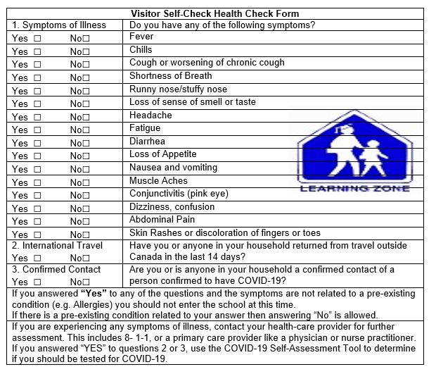

ADMINISTRATIVE MEASURES

Physical Distancing and Minimizing Physical Contact

Physical distancing (i.e. maintaining a distance of two metres between two or more people) will be challenging within School District No. 83, particularly with younger students. As such, it is reasonable to establish different expectations for varying age levels and activities.
For example, younger students should be supported to have minimized physical contact with one another, while older students and adults should seek to maintain a safe physical distance whenever possible.
The following physical distancing strategies should be implemented where possible within School District No. 83: (Note: This includes all related school activities including field trips, fundraising, etc.)

- Avoid close greetings (i.e. hugs, handshakes). Regularly remind students about keeping their “hands to yourself”.
- The number of students in a space should not exceed the ability to maintain health and safety measures.
- Spread people out into different areas. Consider different classroom and learning environment configurations to allow distance between students and adults (i.e. different desk and table formations).
- Stagger recess/snack, lunch and class transition times when possible to provide a greater amount of space for everyone.
- Take students outside more often.
  - Organize learning activities outside including snack time, place-based learning and unstructured time.
  - Take activities that involve movement, including those for physical health and education, outside.
  - Reassure students, parents and caregivers that playgrounds are a safe environment, and encourage appropriate personal hygiene practices before, during, and after outdoor play.
- Incorporate more individual activities or activities that encourage more space between students and staff.
- Utilize barriers for reception areas if possible.
- For adolescent students, minimize group activities and avoid activities that require physical contact.
- Manage flow of people in common areas, including hallways and bathrooms.
- Parents and caregivers and other non-staff adults entering the school should be minimized. They should also be reminded to practice diligent hand hygiene and maintain physical distance when they are in the school.
- Assemblies and other school-wide events should be held within cohorts or held virtually to avoid large gatherings of people in one space.
- Help younger children learn about physical distancing by creating games. Help younger children learn about physical distancing by creating games. Older children can be provided age appropriate reading material and encouraged to self-regulate.
- Regularly clean and sanitize items that are designed to be shared such as manipulatives or electronics. Remove all non-essential toys by covering or storing.
- Set up mini environments within the school to reduce number of children in a group.
- Consider different classroom configurations to maintain distance between children (i.e. separating desks) or different locations in the school (i.e. gym or library, outside).
- Increase the space between children (i.e. use a holla hoop) and staff during activities such as snack/lunch, i.e., move or separate tables, move chairs farther apart.
- Empty sensory bins and cover.
- For K-3 classrooms create personal bins or zip lock bags that contain personal use aid and items.
- Roll up and remove portable carpets.
- Remove cushion and plush animals, puppets, dolls etc.
- Consider staggering snack/lunch time to accommodate smaller groups/more space.
- Discourage any food or drink sharing.
- Use educational videos/online programs or social stories as a part of learning.
- Encourage independent learning and distancing from each other.
- Set up distinct areas for children who may have symptoms of illness until they can be picked up and ensure these areas are sanitized regularly.

Where physical distance cannot be maintained.

- Consider separating people with partitions or plexiglass barriers.
- Where other measures are not sufficient, consider the use of non-medical masks, understanding that these have limitations. Contact HR Coordinator Health Safety and Wellness to access masks.
- Selecting and using masks
- How to use a mask

Communication Plans and Training

- Ensure this Safety Plan is posted on safety board and keep only current copy, as things change there will be updates.
- Ensure safety committee reviews this plan and has the opportunity for feedback.
- Discuss this plan at Staff Meetings.
- Ensure staff and students are aware they are to stay home if they are sick.
- Post signage, including occupancy limits and effective handwashing practices. Signage should also be posted at the main entrance indicating who is restricted from entering the premises (including staff, students, contractors and visitors with symptoms.)

SAMPLE PROTOCOLS TO MAINTAIN SCHOOL ADMINISTRATIVE MEASURES:

Please note the following Administrative Measures are only suggestions and a sample that you may want to include in your plan. The measures created should be dependent upon the school or building.

Photocopy Room
- Depending on the size of the room a max occupancy number may be beneficial to ensure adequate spacing (sign identifying number should be posted)
- Hand sanitizer should be used before and after using the photocopier or other equipment in the room.

Office
- Depending on the size of the office a max occupancy number may be beneficial to ensure adequate spacing and limit the flow of traffic through the office.
- If you choose to keep the exterior doors locked, post contact numbers on front of door so the visitors may access reception.

Daily Announcements
- Office staff should continue to complete daily announcements instead of students.

Crossing Guard Duty
- Staff supervisors will do crossing guard duty without student helpers.

Supervision
- Teacher on recess supervision will be reassigned to morning or afterschool supervision to help with check-in and pick-up.
- CEA’s will be responsible for supervising the students in their Pod at recess and lunch times according to a staggered schedule.

Arrival/Drop-Off and Dismissal/Pick-up

Staff:
- Hand sanitizer will be available to sanitize hands upon entry.
- Proceed to washing hands with soap and water for a minimum of 20 seconds.

Students:

- Students will be instructed as to which entrances of the school to use. Students will be encouraged to remain in their cohorts while entering and exiting the school.
- Lines may be drawn on sidewalk near outside doors to encourage adequate spacing.
- Students will be required to wash hands and or use hand sanitizer upon entering school.

Lunch & Recess

In preparation for Lunch and recess a schedule should be introduced below is a sample of a lunch and Recess schedule:
Eating Time
  - Classes shall eat first so that the teacher can ensure proper hand washing and food preparation.
  - All students will wash hands before eating.
  - There will be no sharing of food.
  - Eating time will occur 15min before the beginning of the scheduled lunch time for each class.
Lunch/Recess
There may be multiple shifts of lunch recess time. CEA’s and Teachers under the direction of the Principal may arrange supervision of students in smaller groups than normal. Each cohort may be assigned a specific space to play according to a schedule.

At the end of lunch/recess students will return to their designated door. Teacher greets students at door and follows classroom entry/handwashing procedure.

A similar schedule will be determined for short recess.

Staff Room
- Limit the amount of staff in staff room. (Post signage)
- Staff can still access the staff room outside their scheduled times, if the maximum number of people is not exceeded.
- Remove excess chairs to ensure adequate space.

Classroom
- Everything utilized within the class room should be able to be cleaned/sanitized.
- At this time School District No. 83 requests that furniture not approved shall not be allowed inside the classroom, this also refers to area carpets for floor teaching.
- For further information please inquire at healthandsafety@sd83.bc.ca.

  - Gym
- As often as possible, students will participate in PE activities outside.
- Ensure activities are non-contact.
- Use of Physical Education equipment shall be scheduled to limit immediate cross-cohort usage.
- Ensure proper cleaning of equipment prior to a new cohort utilizing.

Hallways

- There should be minimal student travel in the hallways except for students going to the washroom.
- Lines may be placed down the center of the hallway for separate traffic flow in support of the “keep right” rule.

Music

- Participation in musical activities can occur outside, in regular classroom or in Music Room.
- If the class is conducted in Music Room ensure all students have access to chairs that can be easily cleaned if seating will be shared.
- If there is a need for carpet use ensure that sanitizing product is utilized and drying time has occurred prior to next class.
- For shared instruments (non-oral) cleaning after each use is mandatory.
- Please refrain from utilizing oral musical instruments unless each student has their own that they bring to class.

Student Washrooms

- Maximum occupancy signs should be posted. This number will vary from two to four depending on the size of the washroom. Click here for Occupancy Limit Poster

Library

- Students should not share library books from teacher’s library. If a book is to be issued wait 24 hours before re-issuing it again.
- If a book is accidentally shared clean your hands after touching a shared book and don’t touch your face, let them sit for 24 hours and they should be good to be redistributed.

Student Behavior

- In addition to the expectations we already have at school, students will also be expected to adhere to the new safety guidelines in place.
- When a student will not follow the Covid-19 safety protocols, (i.e. refusal to physical distance, or wear mask as specified) School District No. 83 will follow standard disciplinary procedures.

Drinking Water

- Water fountains are blocked off and students are asked to bring water from home. Filling stations are available in some schools.
- In many classrooms, students can fill their water bottle at their sink after the water has run for 60 seconds.

Custodial Cleaning Protocols
- School Staff (Administrators, Teachers, Education Assistants)
  - Prop open main entrance doors and/or exterior classroom doors during student intake periods and at the end of classes to minimize hand contact with door hardware.
  - Endeavour to keep all classroom, staffroom and other room doors used open during the day to minimize hand contact with door hardware.
- Frequently-touched shared surfaces will receive Enhanced Environmental Cleaning at least twice a day – minimum midday by the Day Custodian and after school by the Afternoon Custodian.
- All washrooms will receive Enhanced Environmental Cleaning at least twice a day – minimum midday by the Day Custodian and after school by the Afternoon Custodian.
- Custodians will clean and disinfect any surface that is visibly dirty.
- Afternoon Custodians will empty garbage and recycling containers daily.
- Strong Start Centers and childcare operators are required to clean their own tables, counters, toys and chairs.
- Custodians will replenish supplies and also clean door handles (both sides of door and push area above door handle), washrooms and sinks, and vacuum and wash the floors in these spaces.
- Custodian will utilize Buckey Neutral Disinfectant on all surfaces outside of Classrooms.

Student Transportation on Buses

Buses used for transporting students should be cleaned and disinfected according the guidance provided in the BCCDC’s Cleaning and Disinfectants for Public Settings document. Additional guidance is available from Transport Canada.
Bus drivers should clean their hands often, including before and after completing trips. They are encouraged to regularly use alcohol-based hand sanitizer with at least 60% alcohol during trips, as well as wear a non-medical mask or face covering when they cannot physically distance or be behind a physical barrier in the course of their duties.
Students should clean their hands before they leave home to take the bus, when they leave school prior to taking the bus, and when they get home.

Non-medical masks are required for all staff and students between grades 6-12 when riding a school bus.

Non-medical masks are not recommended for elementary students on buses due to the increased likelihood they will touch their face and eyes, as well as required assistance to properly put on and take off their mask (requiring increased close personal contact from school staff).

No student is required to wear a non-medical mask if they do not tolerate it.

Additional Measures:
    - Parents are to ensure home health care check is completed prior to sending student on bus and have answered no to all questions.
    - Students who are sick will need to be kept home, and students who develop symptoms while at school will not be permitted to return home on a school bus and should be picked up by a parent or caregiver. We are not able to transport students who are ill or showing symptoms.
    - Students should ensure their hands have been clean before they leave home and prior to leaving school.
    - Adhere to physical distancing when waiting for the bus.
- Parents will be responsible for their child’s safety at the bus stop. Parents must remain with their child K-5 until the bus departs in the morning and then again meet their child at the bus in the afternoon.
- Middle and secondary school students must wear non-medical masks. No student is required to wear a mask if they do not tolerate it.
- Masks aren't recommended for elementary students on buses because they are more likely to touch their face and may need help putting them on and taking them off.
    - Always follow the driver’s instructions.
    - When loading onto the bus, go to the furthest available seat unless the driver instructs otherwise.
    - When space is available students will be seated in window seat away from aisle.
- When possible, bus routes will utilize a strict seating plan that reflects cohort and family groupings.
    - When unloading the bus, wait until the seat in front has moved before exiting bus, ensure physical distancing is observed.
    - Encouraging private vehicle use and active transportation (i.e. biking, walking, etc.) by students and staff where possible to decrease transportation density.
    - School District No. 83 shall keep up-to-date passenger lists to share with public health should contact tracing need to occur.
    - School buses will not be accepting unregistered riders which includes after-school friends coming home with a bus student.
    - Courtesy drivers will be accommodated as per standard practice. Courtesy riders will be assigned seats as per the seating plan.
- Please see Transportation Safety Plan on the School District website for further information.

Transportation Non-Compliance with COVID-19 Safety Protocols

School District No.83 will follow the standard Discipline Process on Buses. Please see Regulation 5040.06R. Bus Discipline Memo, Bus Discipline Letter.

Food Services

School District No. 83 will continue to include food preparation as part of learning and provide food services, including for sale and meal programs.
    - If food is prepared as part of learning and is consumed by the student(s) who prepared it, no additional measures beyond those articulated in this document and normal food safety measures and requirements need to be implemented (i.e. FOODSAFE trained staff, a food safety plan, etc.).
    - If food is prepared within or outside a school for consumption by people other than those that prepared it (including for sale), it is expected that the WorkSafe BC Restaurants, cafes, pubs, and nightclubs: Protocols for returning to operation are implemented as appropriate and as relevant to the school setting, in addition to normally implemented food safety measures and requirements (i.e. FOODSAFE trained staff, a food safety plan, etc.).
    - Food shall be served by one person only.
    - Previously packaged foods are recommended.
School District No. 83 will not allow homemade food items to be made available to students at this time (i.e. birthday treats, bake sale items).
The June 19th, 2020 Order of the Provincial health Officer Food Service Establishments and Liquor Services does not apply to schools. Food Safety Legislation and the Guidelines for Food and Beverage Sales in B.C. Schools continue to apply as relevant.
School District No. 83 emphasizes that food and beverages should not be shared.

PERSONAL MEASURES

Hand Washing

Thoroughly washing your hands with soap and water is the best protection again illness.
Follow this instruction for handwashing:
- Wet hands with warm running water.
- Apply a small amount of liquid soap. Antibacterial soap is not required.
- Rub hands together for at least 20 seconds (sing the ABC’s). Rub palms, backs of hands, between fingers and under nails/creating a lather.
- If hands are visibly soiled, alcohol-based hand rub may not be effective at eliminating respiratory viruses. Soap and water are preferred when hands are visibly dirty.
- Rinse off all soap with running water.
- Dry hands with a clean, disposable towel.
- Turn off taps, using the paper towel – if required.
- Discard the used towel in the waste container.
Resource: BC Centre for Disease Control | BC Ministry of Health Hand Hygiene;

Strategies to Ensure Diligent Hand Hygiene:
- Encourage hand washing with water and soap upon arrival at school or site.
- Place hand washing stations in various locations including school entrances, hallways, and classrooms to encourage appropriate hand hygiene throughout the day. This measure is unachievable currently; however, we will be exploring availability in fall.
- Consider alcohol-based hand rub dispensers where sinks are not available, and posters to promote the importance of regular hand washing.
- Regularly remind staff and students about the importance of diligent hand hygiene.
- Incorporate additional hand hygiene opportunities into the daily schedule.
- Ensure hand washing supplies are well stocked at all times including soap, paper towels and where appropriate, alcohol-based hand rub with a minimum of 60% alcohol.
- Staff should assist younger students with hand hygiene as needed.

Hand Washing Staff and Children Should Perform Hand Hygiene:

Students
- When they arrive at school
- Before and after any breaks (i.e. recess, lunch).
- Before and after eating and drinking (excluding drinks kept at a student’s desk or locker).
- Before and after using an indoor learning space used by multiple cohorts (i.e. gym, music room, science lab, etc.).
- After using the toilet.
- After sneezing or coughing into hands.
- Whenever hands are visibly dirty.

Staff
- When they arrive at school or site
- Before and after any breaks (i.e. recess, lunch).
- Before and after eating and drinking.
- Before and after handling food or assisting students with eating.
- Before and after giving medication to a student or self.
- After using the toilet.
- After contact with body fluids (i.e., runny noses, spit, vomit, blood).
- After cleaning tasks.
- After removing gloves.
- After handling garbage.
- Whenever hands are visibly dirty.

Hand Sanitizer:

The custodial department will supply each classroom with a bottle of hand sanitizer. Please see custodial if you require a refill. Other bottles of hand sanitizer will be located around facility at the discretion of the principal. Sani Soft SDS
(Custodial Department has ordered portable stations however still under backorder)
How to User Hand Rub:
- Ensure hands are visibly clean (if soiled, follow hand washing steps)
- Apply about a loonie-sized amount to your hands.
- Rub all surfaces of your hand and wrist until completely dry (15-20 seconds)

Coughing and Sneezing Etiquette
- Cough and sneeze into the crease of the elbow or tissue and dispose of tissue into waste bin.
- If there is not tissue cough or sneeze into the bend of your elbow, not your hand, wash hands immediately.
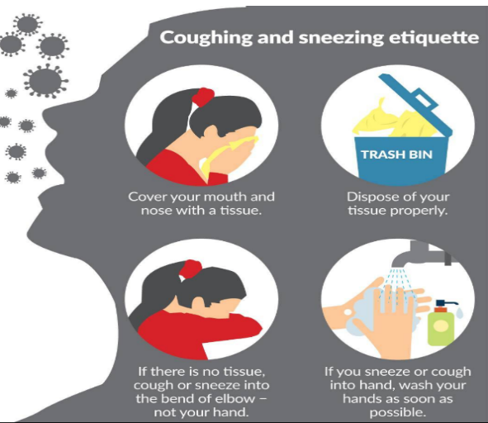

PERSONAL PROTECTIVE EQUIPMENT

PPE:

PPE such as masks and gloves, is not needed for most staff beyond that used as part of routine practices for the hazards normally encountered in their regular course of work.
Students with Medical Complexity, Immune Suppression and/or Receiving Delegated Care Managing students with medical complexities, immune suppression or receiving delegated care may require those providing health services (i.e. staff providing delegated care or other health-care providers) to be in close physical proximity or in physical contact with a medically complex or immune suppressed student for an extended period of time. In community-based clinical settings where there is low incidence and prevalence of COVID-19, additional PPE over and above that required for routine practices is not required.
If a person providing health services assesses the need for additional PPE following a point of care risk assessment it should be worn, refer to student safety plan. Those providing health services should wear a mask when working in proximity with students who are at a higher risk of severe illness due to COVID-19 (i.e. children with immune suppression), particularly those who work at multiple sites.
Those providing health services in schools may be receiving different guidance related to PPE from their regulatory college or employer. They are encouraged to work with them directly to confirm what PPE is recommended for the services they provide in school settings.
No health services should be provided to a student in school who is exhibiting any symptoms of COVID-19 (beyond those detailed if a student develops symptoms at school, as detailed in Appendix B).
While implementation of infection prevention and exposure control measures help create a safe environment by helping to significantly reduce the risk of COVID-19 transmission, it does not eliminate the risk entirely. Parents and caregivers of children who are considered at higher risk of severe illness due to COVID-19 are encouraged to consult with their healthcare provider to determine their child’s level of risk.

Students with Diverse Abilities

Staff or other care providers working with students with diverse abilities (i.e. special needs) should continue with regular precaution. Depending on complexity of a student’s needs an individual Safety Plan may be required, which may include provision of PPE (i.e. mask, glasses and/or face shield).

Non-Medical Masks
Students in grades 6-12 and staff should wear a mask when they cannot safely distance from others outside their cohorts, including crowded common spaces like hallways and school buses.
- Even if wearing masks, students and staff in different cohorts should not crowd in large groups or gather together,
- Students and staff should practice the other safe hygiene etiquette, (i.e. Regular handwashing, physical distancing, cough and sneeze etiquette, and do not touch your face).
- Students and staff will have the option to wear a mask in the classroom.
- Students who don't tolerate face masks for various reasons will not have to wear them
- Everyone must treat each other and those wearing masks with respect
If a student or staff member gets sick at school, they will be asked to wear a mask while they are being assessed by Administration or preparing to go home. Review COVID-19 mask use information from the British Columbia Centre for Disease Control (BCCDC).

School District No. 83 will have non-medical masks or face coverings available for students and staff.

Auditing

There will be an audit of each school and facility by the HR-HSW Coordinator to ensure consistency with this Return to School Safety Plan.
Those Schools and Facilities that are deficient in meeting the requirements will have to present a plan on how they will ensure compliance, and a re-audit will be conducted.

Revision Status
Date | Additions or Deletions | Rationale
June 23, 2020 | Addition of Events - Section12.1 | To satisfy Year End – Revision 4
June 9, 2020 | Addition of Sick While at work Section | To create clarity around process
Aug 5, 2020 | Remove Phase 3 chart and replace with the Stages Chart | To ensure consistency with provincial mandate.  Section 2 BC MINISTRY OF EDUCATION FOUNDATION PRINCIPLES
Aug 5, 2020 | Added Explanation of September Return to school | Section 1 - Introduction
Aug 5, 2020 | Update Links and add links | To ensure the correct information is present.  Section 3 Guidance.
Aug 5, 2020 | Added Section 6 | Safety Measures
Aug 21, 2020 | Updated Section 8 Health and Safety Committee | To ensure compliance with worksafebc.
Aug 5, 2020 | Updated Section 11 Public Health Measures - Cohorts | To ensure definitions are constant with the public health guidelines.
Aug 5, 2020 | Section 13 - What We Know About Covid-19 in Children | Update to include new definitions under public health guidelines.
Aug 5, 2020 | Section 13 - COVID-19 and Schools | Update to include new definitions under public health guidelines.
Aug 5, 2020 | Addition of Section 14 - Infection Prevention and Exposure Control Measures | Update to include new definitions under public health guidelines
Aug 5, 2020 | Section 16 add Case Finding, Contact Tracing and Outbreak Management | Update to include new information around public health responsibilities and guidelines.
Aug 5, 2020 | Section 16 add Self-Isolation for International Travelers Returning to B.C from outside of Canada. | Update to include new information around public health responsibilities and guidelines as they relate to travelers outside of Canada.
Aug 10, 2020 | Section 17.1, Service of Visitors. | Update to include new information around public health responsibilities and guidelines.
Aug 10, 2020 | Section 17.2 Payment of Fees – cash handling. | New process to include cashless payment of student fees.
Aug 7, 2020 | Section 19 Update Health Check for and add Visitor Health Check form, with procedures. | Update to include new information around public health responsibilities and guidelines.
Aug 7, 2020 | Section 22 add Transportation | Update to include new information around public health responsibilities and guidelines.
Aug 7, 2020 | Section 23 Food Services | Update to include new information around public health responsibilities and guidelines.
Aug 7, 2020 | Section 24 – When Student and Staff require hand hygiene. | Update to include new information around public health responsibilities and guidelines.
Aug 7, 2020 | Section 25 – Update PPE | Update to include new information around public health responsibilities and guidelines.
Aug 11, 2020 | Section 26 - Auditing | To ensure consistency within our schools and facilities in regards to compliance.
Aug 7, 2020 | Appendix 9-14 | Update to include new information around public health responsibilities and guidelines.

APPENDIX:

POSTER LINKS:
  - Authorized Personnel
  - Hand Sanitizing Station
  - Hand Washing- Students
  - Hand Washing- Staff
  - Medical Isolation Room
  - Door Posting – Covid -19 Visitor Check List
  - Washroom Cleaning Log
  - How to use a Mask
  - Student Health Check Form
  - Visitor Health Check Form
  - Summary of School Based Control Measures
  - What to Do if a Student or Staff Member Develops Symptoms
  - When to Perform Hand Hygiene at School
  - Occupancy Limit Poster
Video Links

AUTHORIZED PERSONNEL
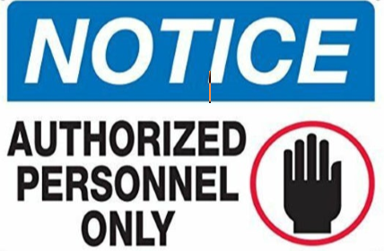

To Contact School Office
Please call:

HAND SANITIZING STATION
- HAND WASHING – STUDENTS
- HAND WASHING – STAFF
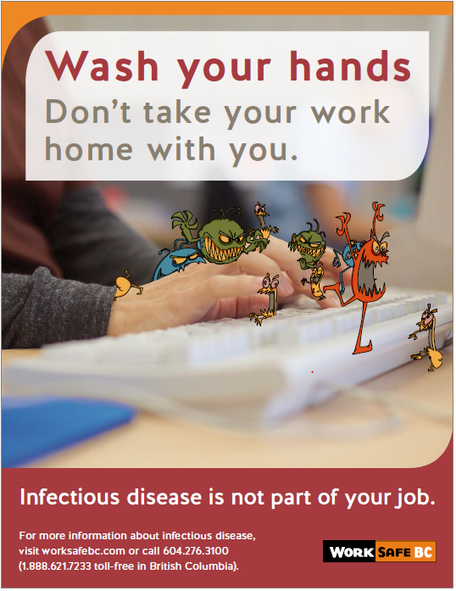HAND
- MEDICAL ISOLATION ROOM
- VISITOR CHECK LIST 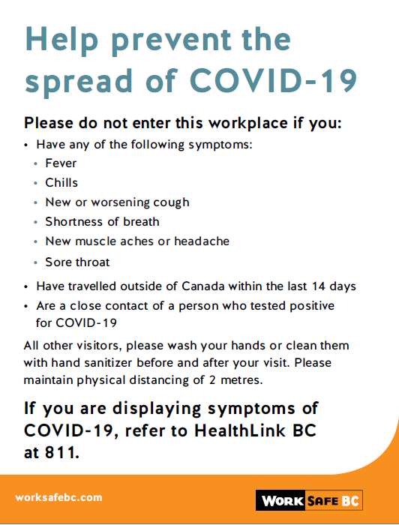

WASHROOM CLEANING LOG
Washroom Cleaning Log
Site:_____________________________ |  |  |  | Room Location: ______________________________
Date | Initial | 7:00 AM | 8:00 AM | 9:00 AM | 10:00 AM | 11:00 AM | 12:00 PM | 1:00 PM | 2:00 PM | 3:00 PM | 4:00 PM | 5:00 PM
June. 1
2
3
4
5
6
7
8
9
10
11
12
13
14
15
16
17
18
19
20
21
22
23
24
25
26

SAFE WORK PROCEDURE: FIRST AID PROTOCOLS – COVID-19

The Board of Education of School District No. 83 (North Okanagan-Shuswap) |  | First Aid Protocols – COVID-19 Pandemic
Department / Area:  All Schools | Approved By:  Brenda Mackay | Date Created:  5/26/2020 | Review / Revised date:  5/26/20 – uncontrolled copy
Potential Hazards:  Fill in those that apply |  |  | Personal protective equipment / devices required / other safety considerations
H M L RISK FOR INJURY  H M L RISK FOR INJURY  ☐☐☐ Broken Glass  ☐☐☐ Radiation Burns  ☐☐☐ Inclement Weather  ☐☐☐Coronavirus ☐☐☐ Traffic  ☐☐☐ Awkward/sustained postures ☐☐☐ Forceful exertions  ☐☐☐ Repetitive motions  ☐☐☐ Vibration ☐☐☐ Skin compression  ☐☐☐ Sharp points / edges  ☐☐☐ Pinch points  ☐☐☐ Material falling ☐☐☐ Falls from Same Level  ☐☐☐ Fall from Height  ☐☐☐ Moving machinery ☐☐☐ Chemicals  ☐☐☐ Biological pathogens  ☐☐☐ Electrical  ☐☐☐ Extreme heat / cold ☐☐☐ Noise  ☐☐☐ Combustibles/flammables  HAZARD ALERT:  Before performing First Aid on a worker be sure to follow all safety protocols outlined below. Failure to do so could result in yourself or your patient becoming ill. |  |  | PPE:  - Gloves  - Face Shield or Surgical Mask  - Glasses or Goggles  - Apron or Lab Coat  - Pocket Mask  Supplies:  - Soap or Hand Sanitizer  - Disinfectant  - Disposable sheets/pillowcases  - Blankets
 |  |  | Training / Reference information
- WorkSafeBC OFAA Protocols
- HealthLinkBC
- BC Centre for Disease Control
- Public Health Agency of Canada
- BC COVID-19 Symptom Self-Assessment Tool
- Hand Hygiene
- How to Wear A Surgical Mask

Note: Signs and symptoms of a musculoskeletal injury (MSI) can include pain, burning, swelling, stiffness, numbness/tingling, and/or loss of movement or strength in a body part. Report these to your supervisor

SCHOOL DISTRICT NO. 83 will ensure that workers are trained and follow this safe work procedure
Steps to perform this task safely.

- Steps to Follow When a Worker Requires First Aid Treatment:

- When First Aid is requested, you need to know:
  - What are the circumstances;
  - Are critical interventions likely required? If so, call 911 or have an emergency transport vehicle prepared:
  - Are there any obvious signs of COVID-19? If so, send the Student or Staff home or to a hospital.

- If no critical interventions are required, if possible and appropriate, interview the patient from a distance. Ask the following questions:
a) is anyone sick or in self-isolation in your household?
b) Have you been in contact with anyone who has been sick?
- When you arrive at the patient’s location, assess the situation:
  - Does the patient have a minor injury that the patient can self-treat while you provide direction and supplies?
  - If yes, direct the patient to self-treat per your OFA protocols (see the self-treatment scenario below).
- If the patient can’t self-treat, don the appropriate level of PPE for the situation. Because the global supply of PPE is scarce, you may need to consider other options.
- After treatment, sanitize all equipment with either soap and water or 70% isopropyl alcohol. Remove and wash any PPE that is not disposable, as well as any exposed clothing. Wash your hands thoroughly.
If critical interventions are required and there is no way of determining background information, don appropriate PPE and limit access to the patient to the number of people required to deal with the critical intervention. It important to limit the exposure of others.
- Scenario: Self-treatment with direction:

A First Aid Attendant receives a call stating a worker has injured her hand. The attendant collects as much information about the severity of the injury as possible. The injury is deemed to be minor with no other concerns, so the attendant goes to the worker, but stays two metres away. On arrival, the attendant asks:
- Is anyone sick or in self-isolation in your household?
- Are you able to administer First Aid to yourself if I tell you what to do and how to do it?
After the First Aid Attendant has conducted the interview, the attendant visually assesses the patient about underlying conditions relating to the injury.
The attendant then places the required First Aid supplies on a surface two metres from the patient. The attendant steps back and directs the patient to pick up and apply the supplies. The First Aid attendant then verbally conducts a modified secondary survey and documents the findings.

- Scenario: OFA Level 1 and Level 2 with intervention:

A First Aid Attendant receives call about a worker who has been struck in the head and is unresponsive. The attendant immediately ensures that 911 is called. On approaching the scene, the First Aid Attendant conducts a scene assessment and dons the appropriate PPE. Once PPE is on, the attendant approaches the patient and conducts a primary survey to determine what, if any, critical interventions are required. The attendant positions the patient in the three-quarter-prone position to ensure that the airway is open and clear and no further interventions are needed. Only one person (the attendant) needs to be in contact with the patient; all others can stay two metres away. The attendant monitors the patient until the ambulance arrives.

Year End Gatherings
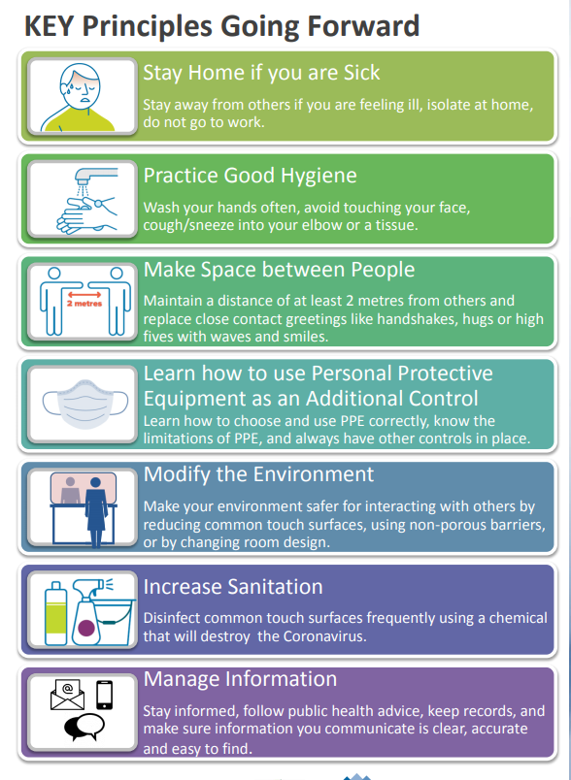

How to Use a Mask
